

Solicitation title & number: Boettcher Mansion Chiller Replacement Project – 26-19289AP-FM
Addendum # 1
Date: 3 November 2026

Submission Due Date:
The due date is now 17 November 2026, no later than 10:00am.

Questions:
The deadline for questions was 29 October 2026 at 10:00am. Questions are no longer being accepted or considered.

This addendum will be posted to BidNet.
Attachments to this Addendum:
- SBT Document – 2864.18_Jeffco Boetcher Mansion Chiller Replacement_Add 1_Elec_2026.11.03.pdf. – The change made to this document was adding a note to the panel schedule for the existing heat trace circuit breaker to be changed out.

- Site Walk Sign-In Sheet

The following clarifications, changes and responses to questions are incorporated into the Solicitation:
- The new due date for bids for this solicitation has been moved to 17 November 2026, no later than 10:00am.

- The new bid opening date for this solicitation has been moved to 17 November 2026 at 2:00pm. See updated Microsoft Teams link below.

Microsoft Teams meeting
Join: https://teams.microsoft.com/meet/22438092957148?p=fz6N1MrXn5HoEO0lE7
Meeting ID: 224 380 929 571 48
Passcode: dH2CJ3Px

Need help? | System reference
Dial in by phone
+1 970-773-5375,,477802983# United States, Grand Junction
Find a local number
Phone conference ID: 477 802 983#
Join on a video conferencing device
Tenant key: jeffco@m.webex.com
Video ID: 114 663 486 0

Q1: Please define all taxes which are applicable to this project and to be carried by the
mechanical/plumbing contractor?

A1: Jefferson County is a tax-exempt entity for state sales tax Acct#09802810.
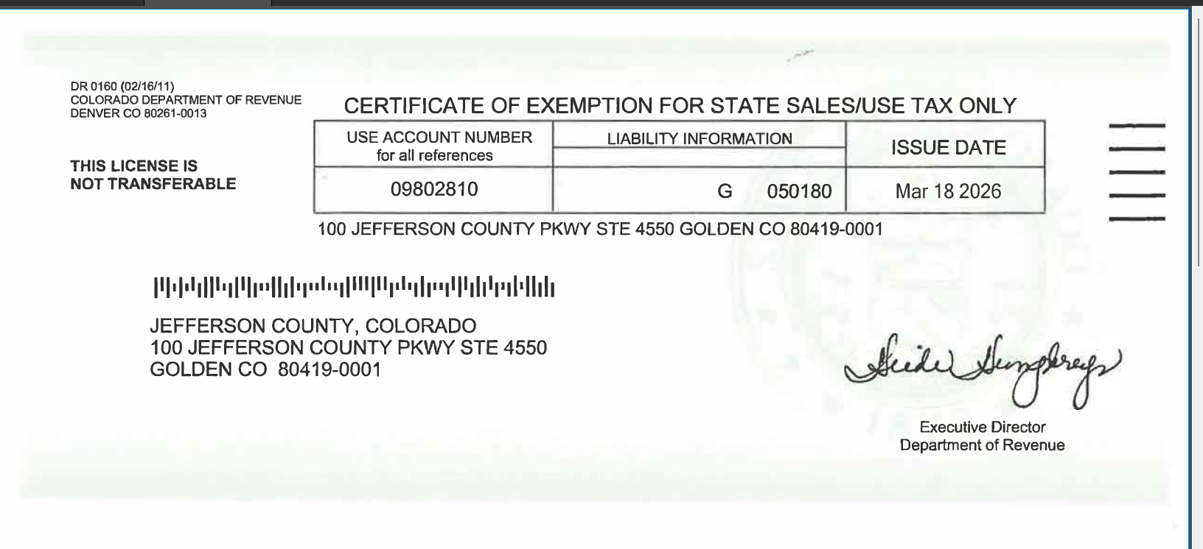

Q2: Sheet E-200 keynote #3 – Will GFEP or GFCI protection be needed on the heat trace?
A2: STB Response: Yes, GFEP or GFCI protection is required. It was understood that the Raychem RayCLIC device has
integral protection but upon further review it does not. We suggest changing the circuit breaker that serves the heat trace
to be a GFEP circuit breaker. We will need to issue a revision to accommodate this.

Q3: Construction documents – Will the testing of cables need NETA (3rd party)
certification?
A3: STB Response: 3rd party testing is not required. Testing should only be needed to check existing circuit viability to ensure
there are no issues with the existing circuiting.

Q4: Will you send out the pre-bid sign in sheet?
A4: Yes, Attached in separate Addendum Document

